TỔNG QUAN
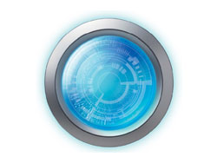

All in One Imaging Solution: Observation, Image Capture, Measurement, and Sharing
The DSX510 digital microscope is an easy-to-use, all-in-one imaging system designed to provide detailed analysis and reports. An intuitive touch screen-based user interface and up to 9,000x magnification enable users of various experience levels to obtain reliable measurement and inspection results.

Observation
- Clear, high-resolution image
- Choose from multiple observation methods with a single click
- Easy to operate
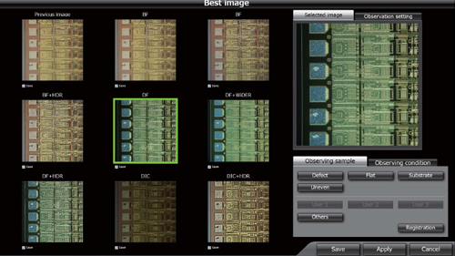

Image Capture
- 3D images highlight your samples' true shape
- Obtain all-in-focus images, even for samples with projections
- Automatically acquire panoramic images
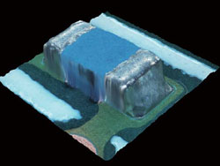

Measurement
- Guaranteed measurement accuracy*
- Versatile measurement and analysis tools
- Measure the roughness of surfaces
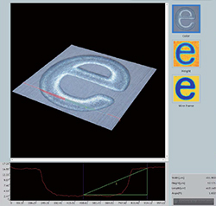

Sharing
- Create reports with one click
- Variety of report formats
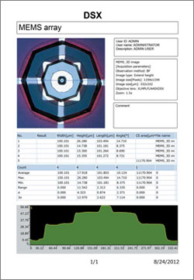

*The accuracy guarantee is based on conditions set by Olympus

